Grafana and Prometheus
Grafana
Grafana is a free, open-source tool that helps you monitor and visualize data from systems like servers, apps, and Kubernetes clusters.
Think of it as a dashboard maker: it pulls data (like CPU usage or app performance) from sources such as Prometheus, then shows it in easy charts, graphs, gauges, or tables that update in real-time. You can set alerts if something goes wrong, like high memory use, and customize views for your needs.
Why for Beginners in DevOps
It connects to tools you know, like Prometheus for metrics or AWS CloudWatch, making it perfect for watching your EKS apps without complexity. Start by installing via Docker (docker run -d -p 3000:3000 grafana/grafana), log in (admin/admin), add Prometheus as a data source, and build your first dashboard in minutes.
Prometheus
Prometheus is a free, open-source tool that collects and stores performance data (like CPU, memory, or app metrics) from servers, apps, and Kubernetes clusters over time.
It works like a watchful robot: it "pulls" numbers from your systems every few seconds via HTTP, saves them in its own database, and lets you query them with PromQL (a simple search language). You can set alerts if something's wrong, like high CPU, and it pairs perfectly with Grafana for pretty charts.
Why for Beginners in DevOps
In your EKS setups, run it as a Docker container or Helm chart to monitor pods and nodes automatically. Quick start: Download the binary, edit prometheus.yml to scrape targets (e.g., localhost:9100), and launch ./prometheus—data shows up at localhost:9090 in minutes..

Why grafana and promotes is popular?
Grafana and Prometheus dominate monitoring due to their free open-source nature, seamless Kubernetes integration, and powerful combo for real-time observability in cloud-native DevOps.
Container-Native Design: Prometheus pulls metrics from dynamic pods/services automatically, while Grafana visualizes them instantly—ideal for EKS/micro services like your 3-tier app.
Flexibility and Ecosystem: 50+ data source plugins in Grafana (PromQL queries, Loki logs, Tempo traces) plus Helm charts for one-click deploys make them beginner-friendly yet enterprise-scale
Cost-Effective Power: No licensing fees, unlike Datadog/New Relic; community dashboards/alerts speed setup for CI/CD pipelines.

Node Exporter
Node Exporter is a lightweight Prometheus tool that runs on each server or Kubernetes node to collect basic system metrics like CPU, memory, disk, and network usage.
Node Exporter acts like a spy on your server's hardware and OS, sharing stats like CPU, RAM, disk space, and network speed on port 9100.​
Prometheus grabs this data every few seconds (pull model), while Grafana turns it into easy charts—separate from container metrics (like cAdvisor handles).
------------------------------------------------------------------------------------------------------------------------------------
Learning purpose we have created 2 Server in AWS
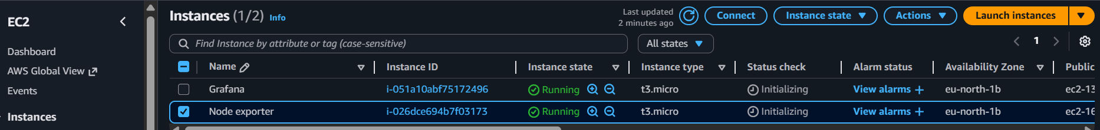
- Grafana
- Node exporter

Installation
Installing Grafana on server named grafana.
Step1:
Grafana download (click on this link to install grafana on server, here we have choose which Linux os we want such as Ubuntu , RHEL)

https://grafana.com/grafana/download
Here, we are using RHEL (Red Hat, CentOS, RHEL, and Fedora) so we go for:-
installation script:
sudo yum install -y https://dl.grafana.com/grafana-enterprise/release/12.3.0/grafana-enterprise_12.3.0_19497075765_linux_amd64.rpm
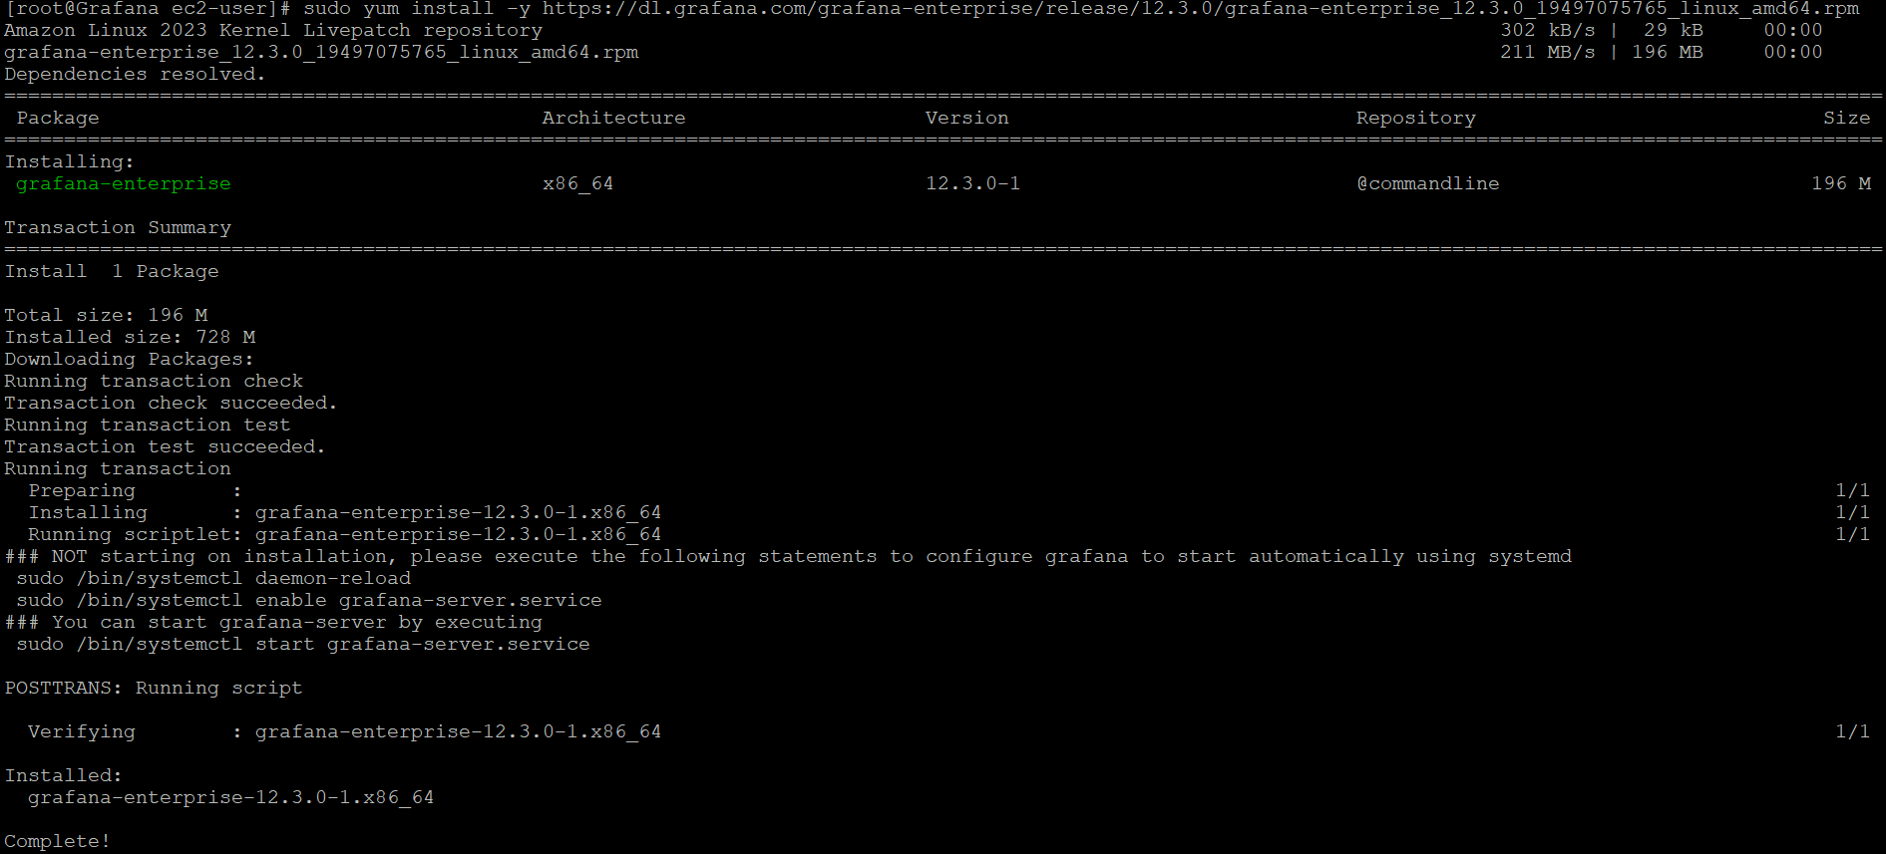

Step 2: Run this below command to reload the demon
sudo /bin/systemctl daemon-reload
sudo /bin/systemctl enable grafana-server.service
sudo /bin/systemctl start grafana-server.service
Note:
- What is the use of daemon-reload?
Systemctl daemon-reload reloads the systemd manager configuration without restarting the system or any services.
Safe for production; does not restart services or disrupt running processes.
- When should I run systemctl daemon-reload?
Run systemctl daemon-reload immediately after modifying, creating, or deleting any systemd unit files, such as .service, .timer, or drop-in files in directories like /etc/systemd/system/ or /lib/systemd/system/

- What it does (systemctl enable grafana-server. Service)
sudo systemctl enable grafana-server.service sets Grafana to start automatically every time the server boots.
Run it after installing Grafana or editing its service file, but first do sudo systemctl daemon-reload if changes were made.​
It creates symlinks so systemd knows to launch Grafana on startup, without starting it right away

Gafana is up and running
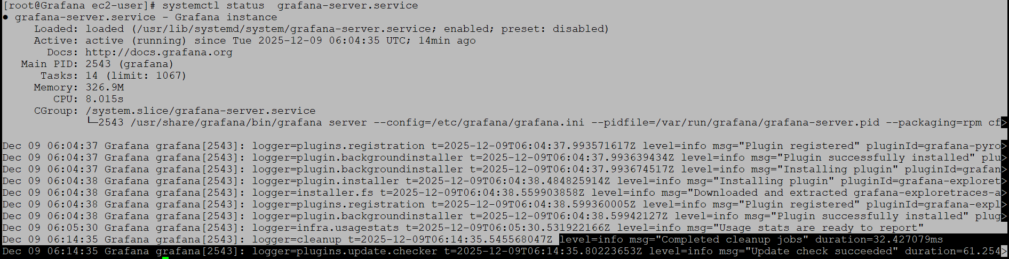

Note :
The default HTTP port for Grafana is 3000
IP address: 3000

For example:


Note: same time issue arrives
we have do some configuration in etc folder
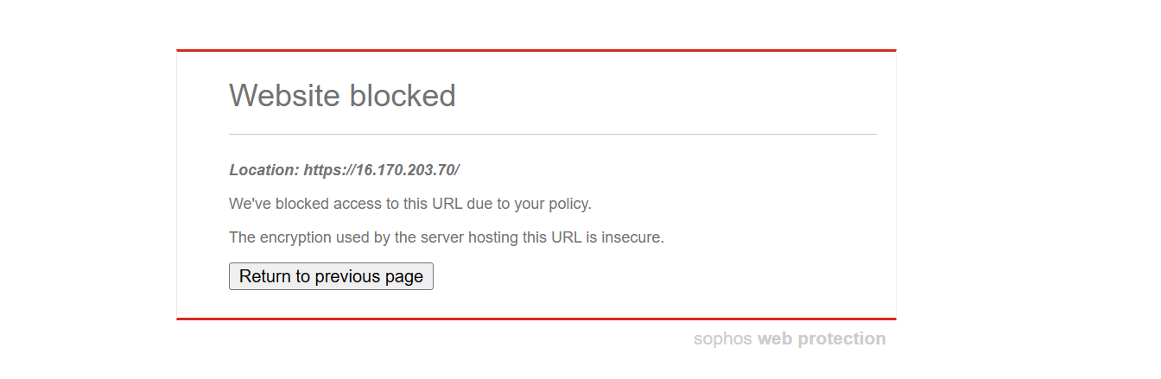
Use Grafana on HTTP inside your network and avoid HTTPS on the IP:
Edit Grafana config (/etc/grafana/grafana.ini):
In [server] section:
protocol = http
http_port = 3000
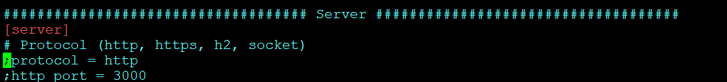

What this configuration does?
protocol = http
Tells Grafana to listen using plain HTTP, not HTTPS; TLS is completely disabled in Grafana.​ When we have a proper domain name we can go for HTTPS.
http_port = 3000
Sets the listening port to 3000 (Grafana’s default web port).
sudo systemctl restart grafana-server
Restarts the Grafana service so it actually uses the new HTTP configuration.​
Accessing http://16.170.203.70:3000
opens the Grafana UI over HTTP to that IP and port; the browser no longer negotiates HTTPS with Grafana, which avoids the “encryption is insecure” issue from Sophos for that endpoint (assuming your firewall allows plain HTTP to that internal IP).

Username: Admin
Password: Admin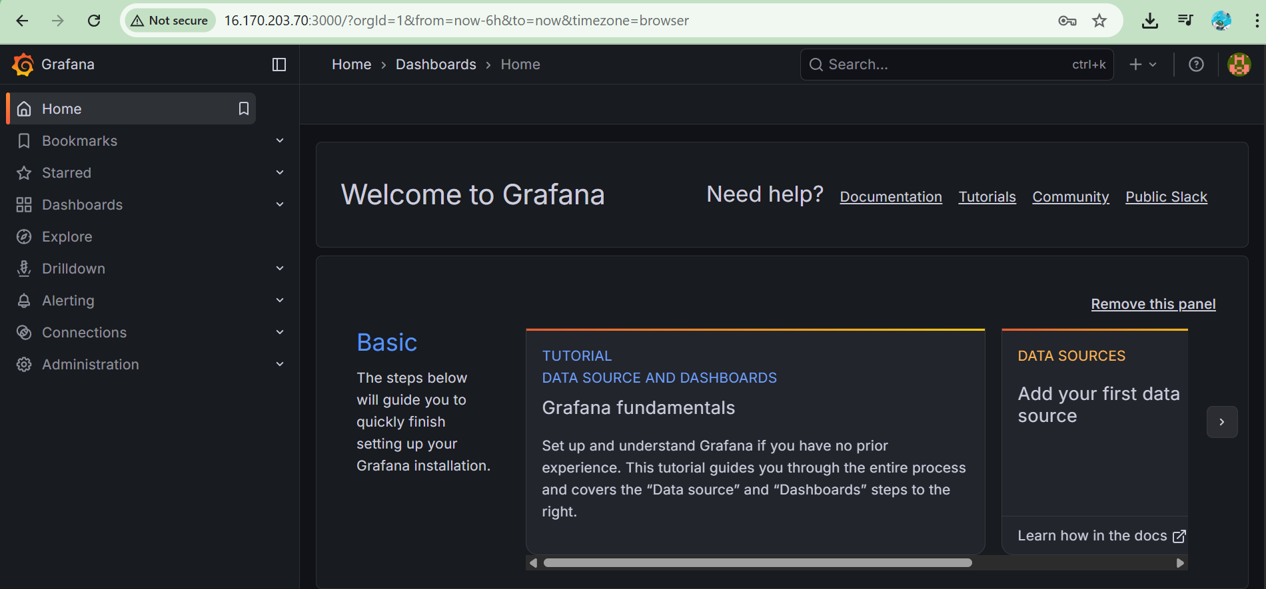

----------------------------------------------------------------------------------------------------------------------------------


We have installed grafana on sever. Grafana only gives visual but it not give any metrics. Using Prometheus build the metrics. Grafana like webpage and Prometheus is like data source
Now we are installing Prometheus.

Installation Prometheus:-

Step1:-
Go to below website and select the tar file.
https://prometheus.io/download/#prometheus

wget https://github.com/prometheus/prometheus/releases/download/v3.8.1/prometheus-3.8.1.linux-amd64.tar.gz
Using wget command we are downloading tar file local machine.

Then,
We have to extract the tar file.
tar xvfz prometheus-3.8.1.linux-amd64.tar.gz
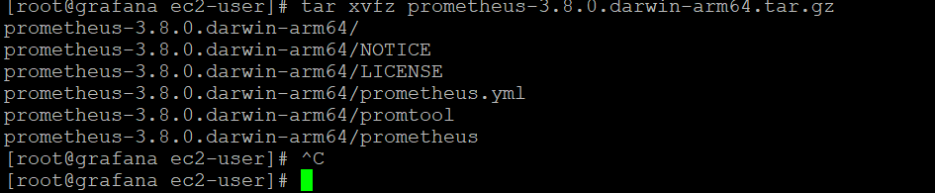

Step2:
Create two new directories for Prometheus to use. The /etc/prometheus directory stores the Prometheus configuration files. The /var/lib/prometheus directory holds application data.
sudo mkdir /etc/prometheus /var/lib/prometheus
Simple definition :
/etc/prometheus : Folder for Prometheus configuration files.
/var/lib/prometheus : Folder for Prometheus data (metrics storage).
/etc/prometheus
- Holds Prometheus config files such as prometheus.yml, alerting rules, and console templates.
This is the standard place on Linux for service configuration, so configs are easy to manage, back up, and version-control.
/var/lib/prometheus
- Holds Prometheus’s time-series database: all scraped metrics, WAL, and block files.
/var/lib is the usual location for persistent application data, so Prometheus data survives reboots and service restarts.
Step3:
Moving the file to respective folder

sudo mv prometheus promtool /usr/local/bin/
sudo mv prometheus.yml /etc/prometheus/prometheus.yml
sudo mv consoles/ console_libraries/ /etc/prometheus/
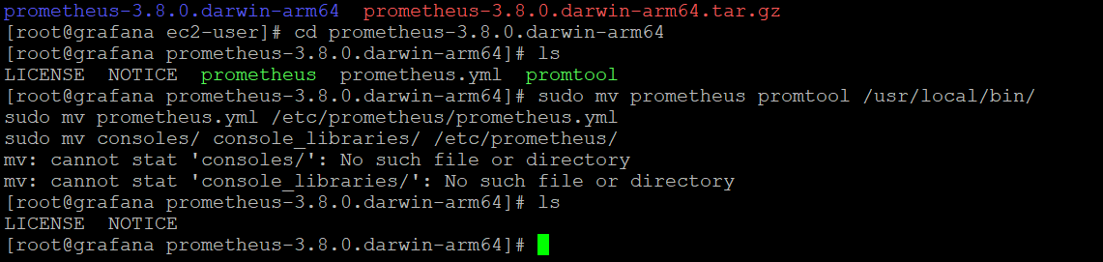
Explanation for above command

sudo mv prometheus promtool /usr/local/bin/
Moves the prometheus server binary and the promtool helper into /usr/local/bin so they are in PATH and can be run from anywhere like normal system commands.
sudo mv prometheus.yml /etc/prometheus/prometheus.yml
Moves the main Prometheus configuration file into the config directory you created earlier.
sudo mv consoles/ console_libraries/ /etc/prometheus/
Moves the HTML console templates and their libraries into /etc/prometheus/ so Prometheus can use them for its built-in web UI consoles.

Step 4: Adding Prometheus user

Configure Prometheus to run as a service run this command

sudo useradd -rs /bin/false prometheus
sudo chown -R prometheus: /etc/prometheus /var/lib/prometheus

Those two commands prepare Prometheus to run safely as a systemd service under its own restricted user.
sudo useradd -rs /bin/false prometheus
Creates a dedicated system user named prometheus with no login shell and no home directory.
This user will run the Prometheus process, limiting damage if Prometheus is compromised and following least-privilege best practices.​
sudo chown -R prometheus: /etc/prometheus /var/lib/prometheus
Gives the prometheus user ownership of the config directory and data directory.
This allows the Prometheus service (running as that user) to read its configs and write time-series data, while other users/processes cannot modify these directories directly.​
-----------------------------------------------------------------------------------------------------------------------------------
Step 5: creating demon file
That file is a systemd unit file; creating it tells Linux how to run Prometheus as a managed background service instead of a one-off process.
Why this file is needed
It lets you control Prometheus with standard commands: sudo systemctl start|stop|restart|status prometheus.
It makes Prometheus start automatically on boot (WantedBy=multi-user.target) and restart if it crashes (Restart=on-failure)
.
What the main parts do
[Unit]
Ensures Prometheus starts after the network is online (Wants/After=network-online.target).
[Service]
User=prometheus / Group=prometheus: run it as the dedicated, non-login Prometheus user for security.
ExecStart=...: exact command to launch Prometheus with paths to config, data directory, console templates, listen address, etc.
Restart=on-failure and RestartSec=5s: auto-restart after failures with a 5-second delay.
[Install]
Hooks the service into the normal multi-user runlevel so systemctl enable prometheus makes it start on every reboot.
sudo vi /etc/systemd/system/prometheus.service
---
[Unit]
Description=Prometheus
Wants=network-online.target
After=network-online.target
[Service]
User=prometheus
Group=prometheus
Type=simple
Restart=on-failure
RestartSec=5s
ExecStart=/usr/local/bin/prometheus \
--config.file /etc/prometheus/prometheus.yml \
--storage.tsdb.path /var/lib/prometheus/ \
--web.console.templates=/etc/prometheus/consoles \
--web.console.libraries=/etc/prometheus/console_libraries \
--web.listen-address=0.0.0.0:9090 \
--web.enable-lifecycle \
--log.level=info
[Install]
WantedBy=multi-user.target
---
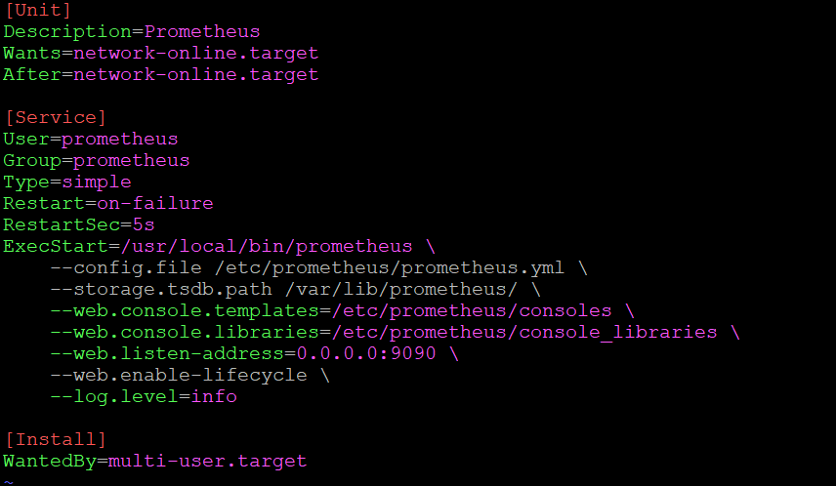
Step 6:
- Reload Daemon service and enable prometheus to start post reboot
sudo systemctl daemon-reload
sudo systemctl enable prometheus

Step7:
Start the Prometheus

sudo systemctl start prometheus
sudo systemctl status prometheus
----------------------------------------------------------------------------------------------
Note: Some is showings status like Activating
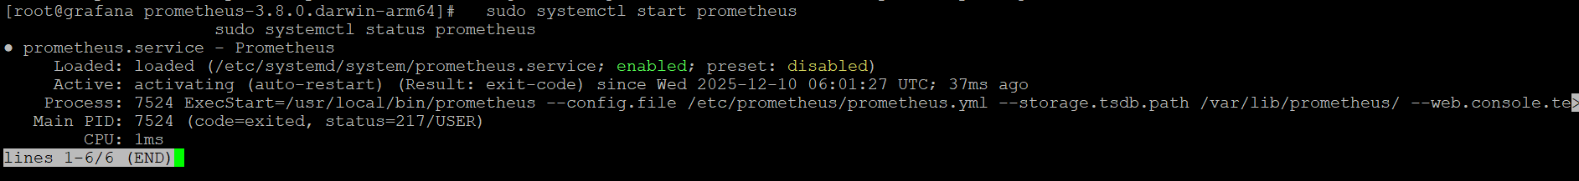
What to check and fix
Confirm the user exists:
Run: getent passwd prometheus
If nothing is returned, create it:
sudo useradd -rs /bin/false prometheus
Ensure ownership of Prometheus dirs:
sudo chown -R prometheus: /etc/prometheus /var/lib/prometheus
Reload and restart:
sudo systemctl daemon-reload
sudo systemctl restart prometheus

Then check: sudo systemctl status prometheus
If the user already exists, double-check the User= and Group= lines in /etc/systemd/system/prometheus.service for typos and that both say exactly prometheus.
--------------------------------------------------------------------------------------------
Step 8:
IP address: 9090
Yes, 9090 is the default HTTP port for the Prometheus server.
So you normally access it at: http://<server-ip>:9090 (for example, http://16.170.x.x:9090)
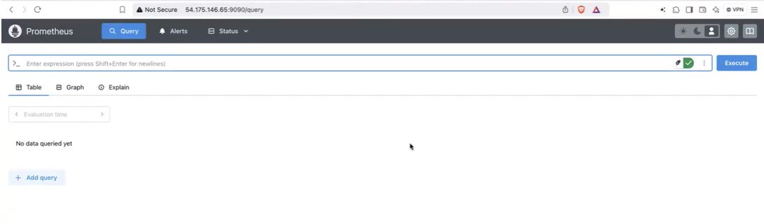

Note: Access Prometheus
You can now login to http://IP_Address:9090 to access Prometheus GUI. If you can't access the page it can be either because prometheus service is not started or port is not allowed from outside world.

Commands to open firewall ports on centos 7
- Check ports which are allowed
sudo firewall-cmd --zone=public --list-ports
- Allow 9090 port
sudo firewall-cmd --zone=public --add-port=9090/tcp --permanent
sudo firewall-cmd --reload

We have installed both grafana and Prometheus
---------------------------------------------------------------------------------------------
Integrate the grafana and prometheus
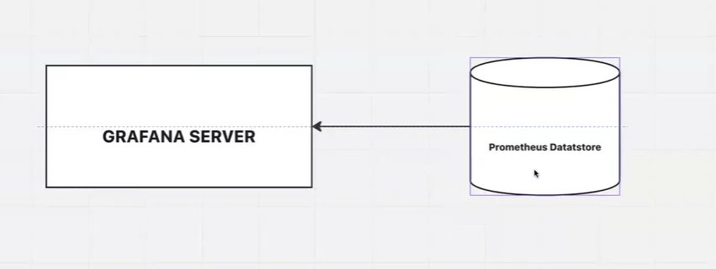

Prometheus stores time-series metrics in its own database, and Grafana reads those metrics (via Prometheus’s HTTP API) to display them in dashboards and panels.
For example we 10 server
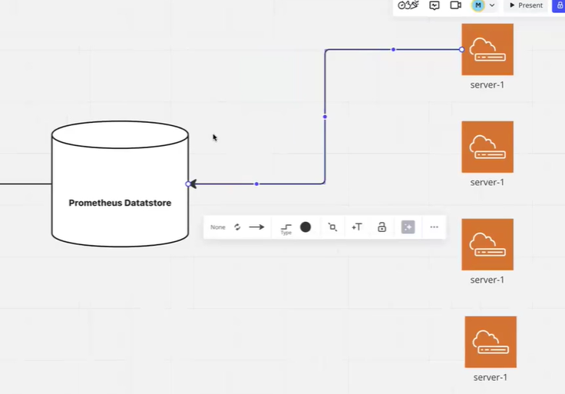

Prometheus will read the metric from server and that metrics will displayed using grafana.
Read the metrics form the server we use the node exporter.
Node exporter

Note: install the node exporter on target server or which server need to monitor. Node exporter is server level.
Overview
node_exporter is a Prometheus exporter for collecting and exposing various metrics related to a Linux or UNIX system. It is part of the Prometheus monitoring and alerting ecosystem and serves as a fundamental component in gathering system-level metrics.
Here's a brief overview of what node exporter does:
System Metrics:
Collects general system-level metrics such as CPU usage, memory usage, disk I/O, and network activity. Provides information about the overall health and performance of the system.

Step 1: Download and extract Node Exporter

wget https://github.com/prometheus/node_exporter/releases/download/v1.10.2/node_exporter-1.10.2.linux-amd64.tar.gz
Step 2: Extract Node Explorer
tar -xzvf node_exporter*.gz

Step 3:
Create a user which we will use to run node exporter service Username: nodeusr
sudo useradd -rs /bin/false nodeusr

Step 4: Configuring Node Exporter to run as a service
Create a file
sudo touch /etc/systemd/system/node_exporter.service
sudo vi /etc/systemd/system/node_exporter.service

write below content in the file. By default node_exporter runs on port 9100 , you can change it if required and specify a different port in --web.listen-address

----
[Unit]
Description=Node Exporter
After=network.target

[Service]
User=nodeusr
Group=nodeusr
Type=simple
ExecStart=/usr/local/bin/node_exporter --web.listen-address=:9100

[Install]
WantedBy=multi-user.target
----

The default port number for node exporter is 9100.

Step 5: Move Node exporter file to
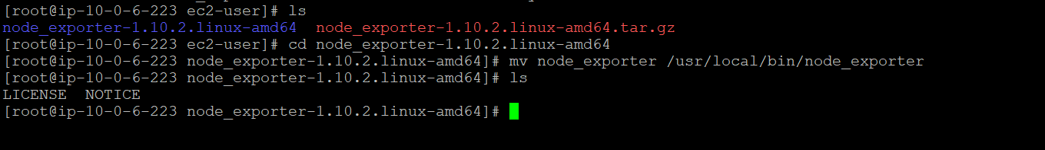
to inside the Node exporter file (Extracted folder)

mv node_exporter /usr/local/bin/node_exporter



STEP 5: Start node_exporter service

sudo systemctl daemon-reload
sudo systemctl start node_exporter
sudo systemctl enable node_exporter
sudo systemctl status node_exporter

Copy the ip address of the target server and port value:

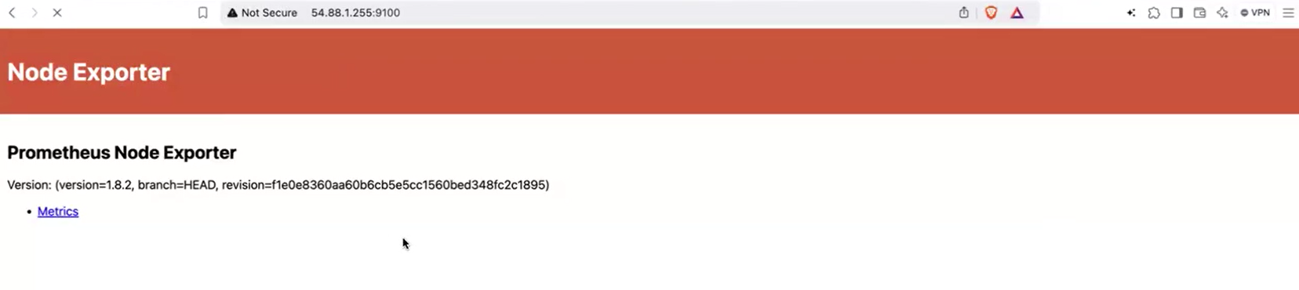

GO TO grafana server.

This the metric of the target server, that need to added to Prometheus and displayed in grafana.

Establishing the connection between grafana, Prometheus and node exporter.Go to grafana server:

Prometheus Configuration File Location
Prometheus YML file is located at following /etc/prometheus/prometheus.yml Here is what a default configuration file will look like.

Vi /etc/prometheus/prometheus.yml
---
# my global config
global:
scrape_interval: 15s # Set the scrape interval to every 15 seconds. Default is every 1 minute.
evaluation_interval: 15s # Evaluate rules every 15 seconds. The default is every 1 minute.
# scrape_timeout is set to the global default (10s).

# Attach these labels to any time series or alerts when communicating with
# external systems (federation, remote storage, Alertmanager).
external_labels:
monitor: 'codelab-monitor'

# Load rules once and periodically evaluate them according to the global 'evaluation_interval'.
rule_files:
# - "first.rules"
# - "second.rules"

# A scrape configuration containing exactly one endpoint to scrape:
# Here it's Prometheus itself.
scrape_configs:
# The job name is added as a label `job=<job_name>` to any timeseries scraped from this config.
- job_name: 'prometheus'

# metrics_path defaults to '/metrics'
# scheme defaults to 'http'.

static_configs:
- targets: ['localhost:9090',"44.210.237.232:9100"]
----
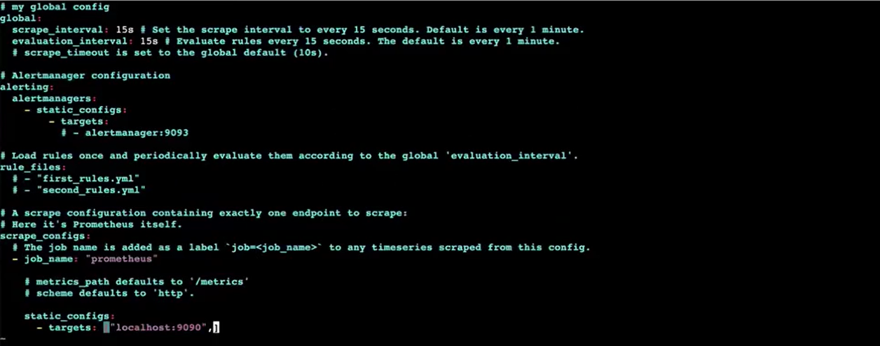
static_configs:
- targets: ['localhost:9090',"44.210.237.232:9100"]

Static section we have to put the target server ip address and port value:

systemctl restart prometheus

arget server or resource is added in promotes dashboard

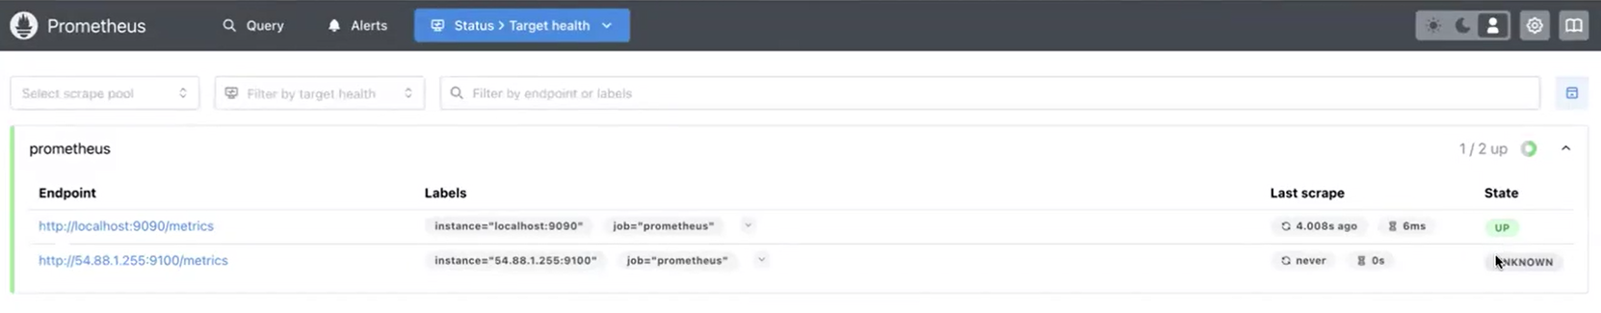

Goto grafana dashboard
https://grafana.com/grafana/dashboards/
Look for node exporter dashboard

Copy the ID of node exporter

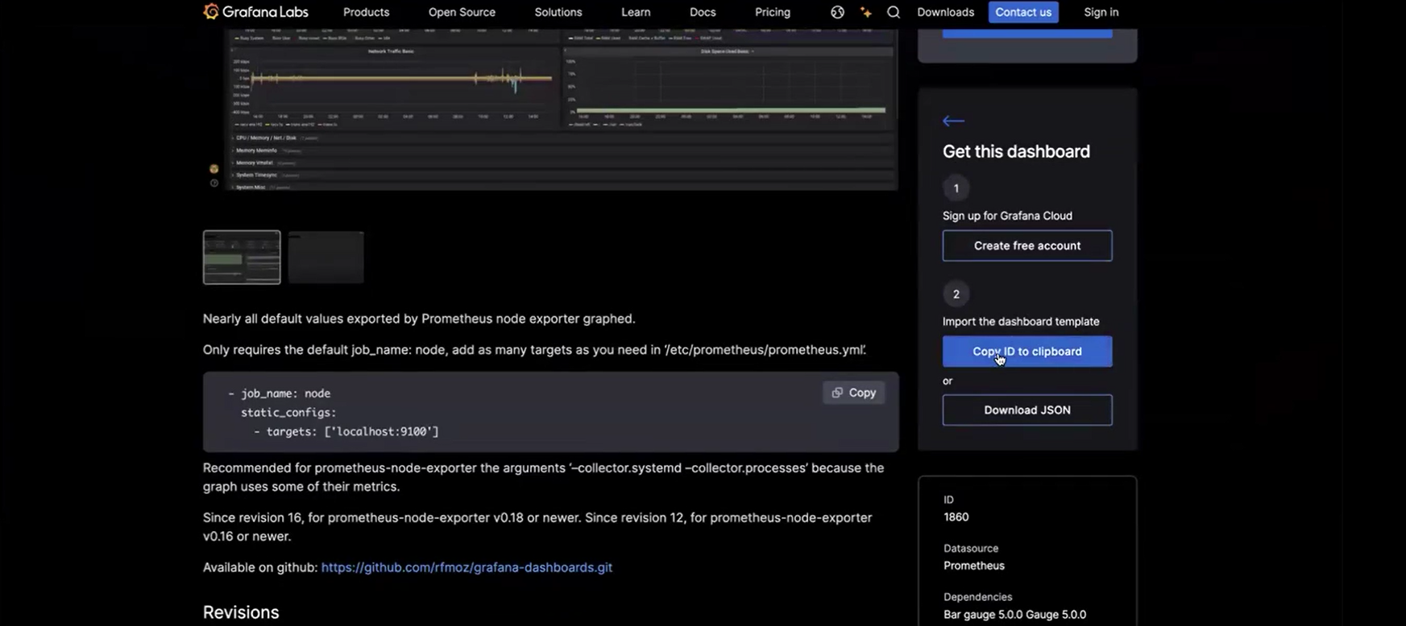

Go to grafana

Click on data source:

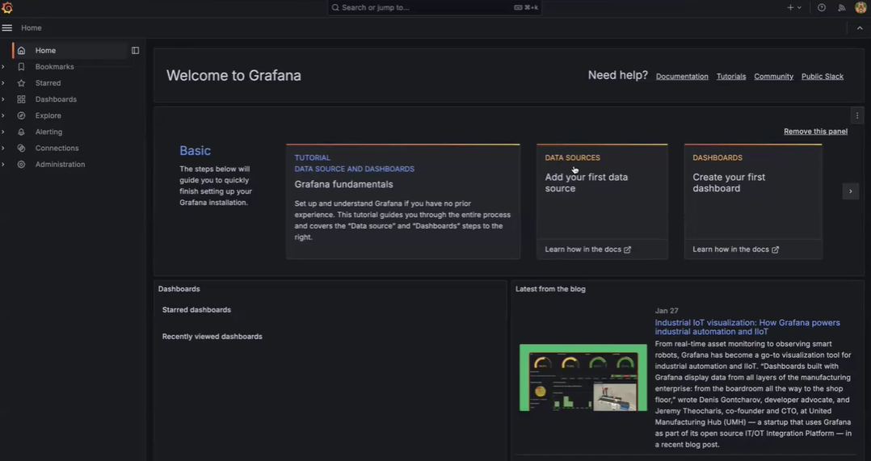

Select Prometheus

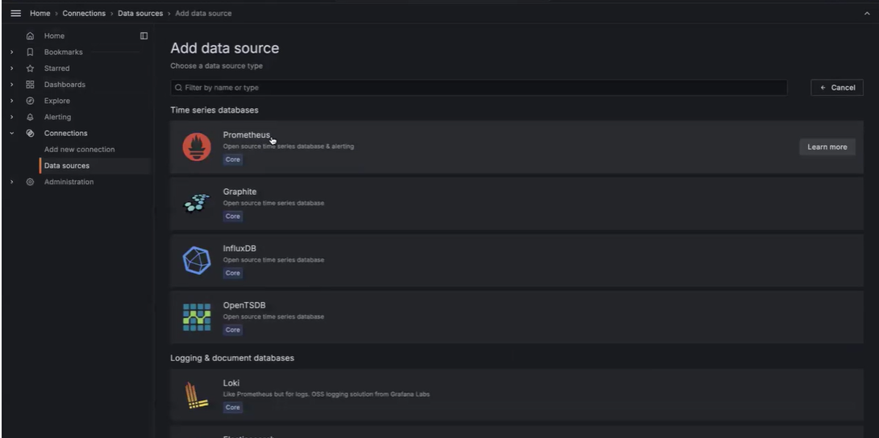

Add the url of the Prometheus in the grafana

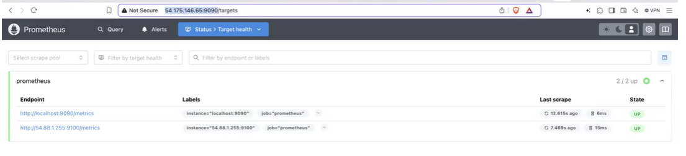

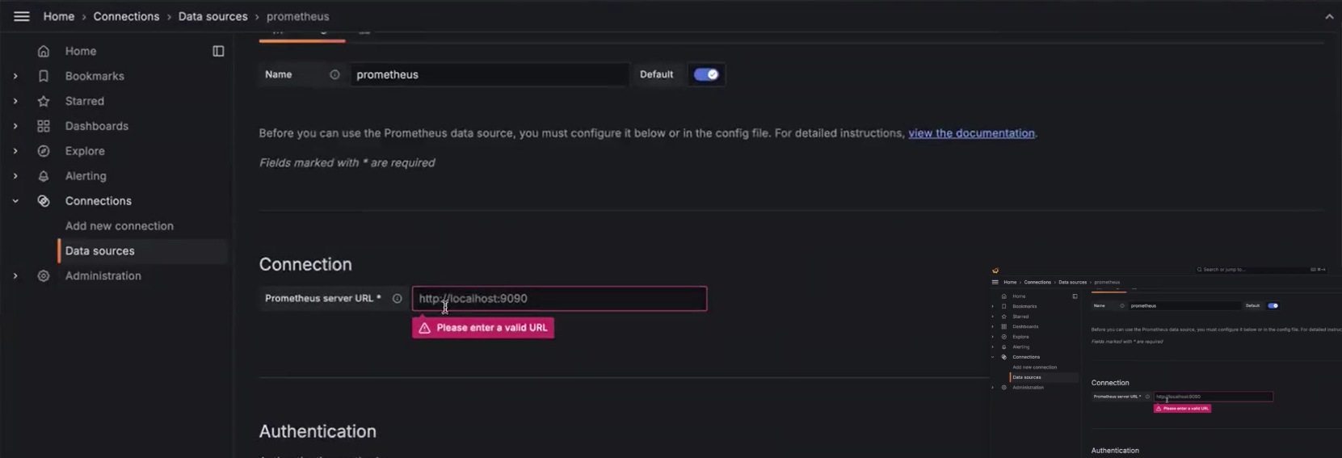

Save and test

Go to dashboard
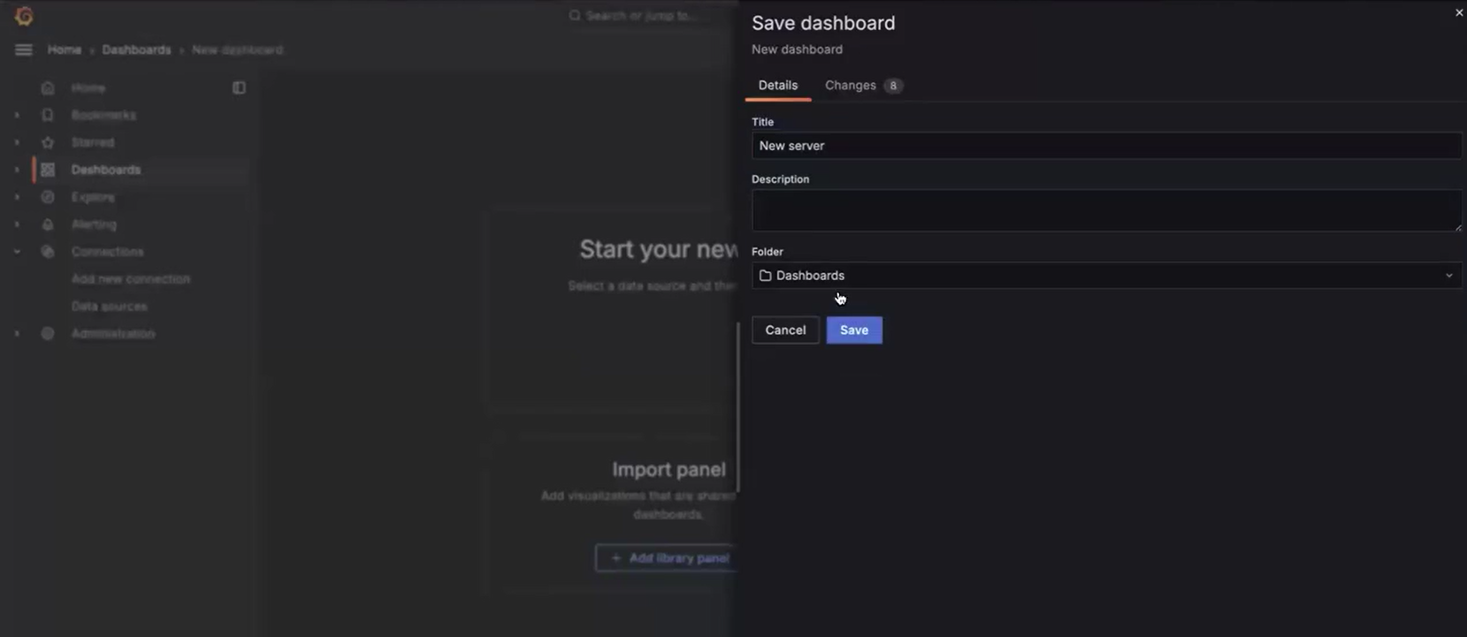
Paste the copy id here

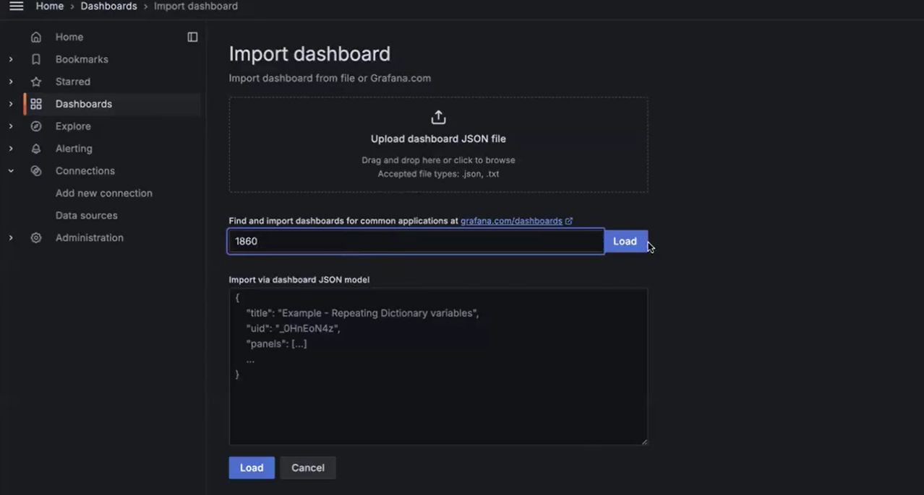

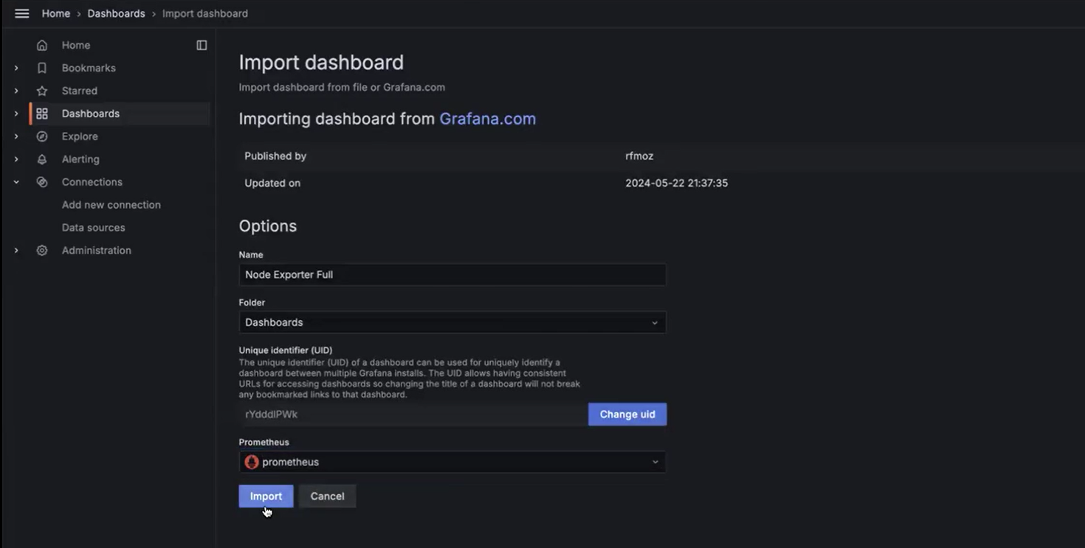
Importing the dashboard is completed.
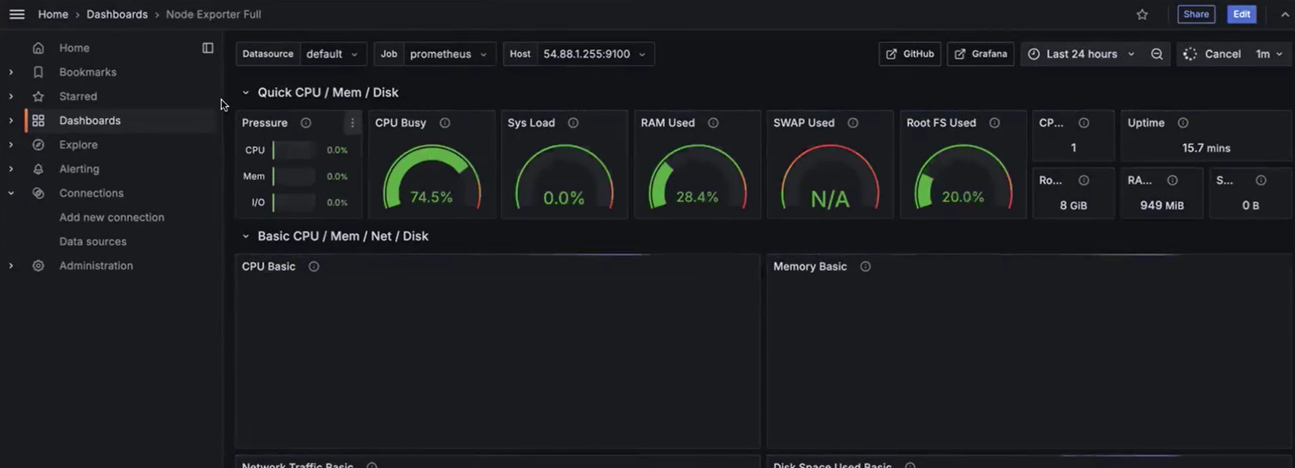

For demo
Stress Test
A stress test is a way to push a system to (or near) its limits to see how it behaves under extreme load.
You generate very high CPU, memory, disk, or network load (often more than expected in production) for some time.
You observe performance, errors, and resource usage to find bottlenecks, breaking points, and stability issues.
Why it’s used
Validate that systems remain stable under peak or unexpected load.
Reveal scaling limits, resource shortages, and misconfigurations before real users hit them.
command:
sudo amazon-linux-extras install epel -y
sudo yum install stress -y

We putting the load on server, now we can see that cup is busy

nohup sudo stress --cpu 8 -v --timeout 30000 &
nohup sudo stress --cpu 8 -v --timeout 30000 &
nohup sudo stress --cpu 8 -v --timeout 30000 &
nohup sudo stress --cpu 8 -v --timeout 30000 &
nohup sudo stress --cpu 8 -v --timeout 30000 &
nohup sudo stress --cpu 8 -v --timeout 30000 &
nohup sudo stress --cpu 8 -v --timeout 30000 &
nohup sudo stress --cpu 8 -v --timeout 30000 &
Those commands start 8 background stress processes, each using 8 CPU workers, so you’re heavily loading all CPU cores for a long time.
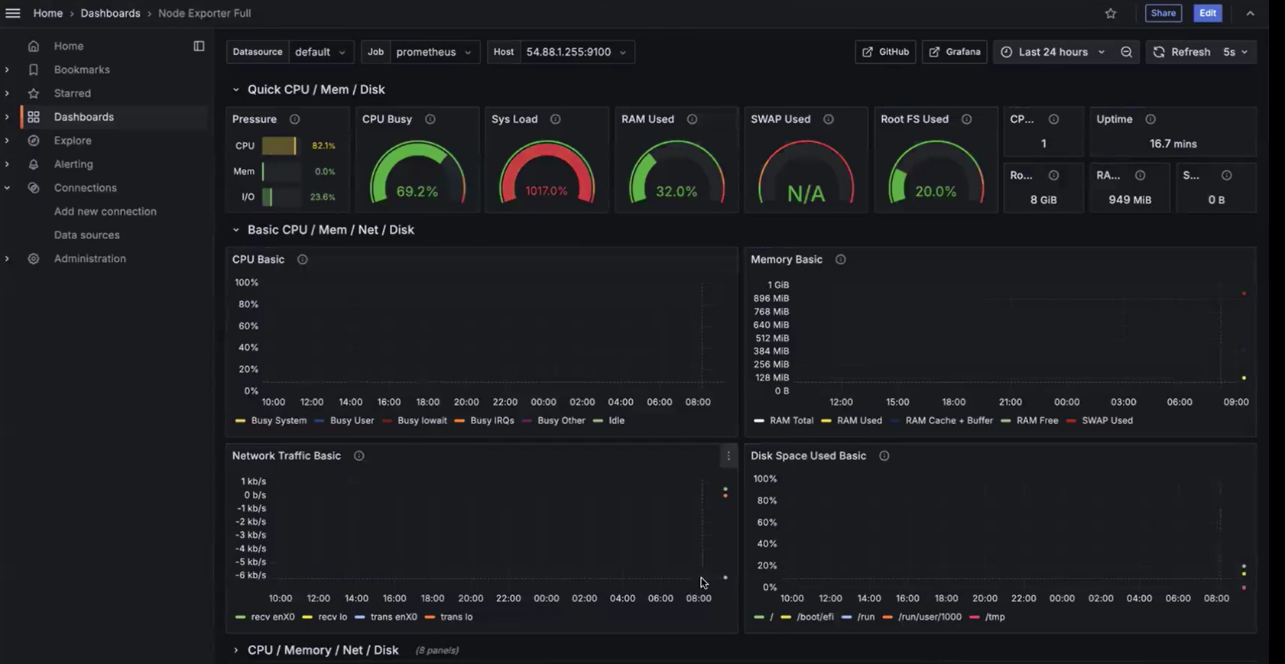

Killing stress process:
for i in $(ps -ef|grep -i stress|awk '{print $2}'); do kill -9 $i; done
ps -eo pid,ppid,cmd,%mem,%cpu --sort=-%mem | head
--------------------------------------------------------------------------------

In /etc/prometheus/, create these essential YAML files for production monitoring
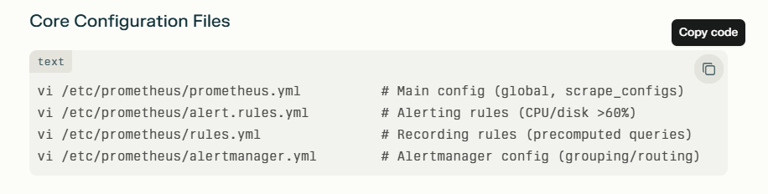
1) prometheus.yml

Prometheus.yml stores target server IP addresses (or hostnames) under static_configs for servers with Node Exporter installed on port 9100.
Static Targets Configuration
Add servers running Node Exporter to prometheus.yml
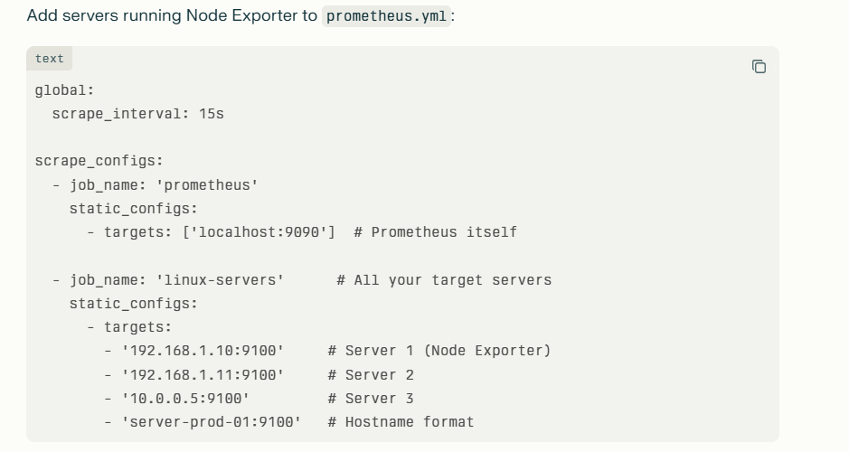

---------------------------------------------------------------------------------------------------------
2) alert.rules.yml
it is like a watchdog list that tells Prometheus: "Check these problems every 15 seconds and bark (alert) if something's wrong for 2 minutes."
# Save this as alert.rules.yml
groups:
- name: my_servers
rules:
- alert: "CPU Too High!" # Alert name
expr: avg(rate(node_cpu_seconds_total{mode!="idle"}[5m])) * 100 > 60
for: 2m # Wait 2 minutes
labels: { severity: "warning" } # Alert type
annotations:
summary: "Server {{ $labels.instance }} CPU is {{ $value | printf "%.0f" }}%"

Grafana shows red alert badge. Slack pings: "🚨 CPU Too High! Server web01 CPU is 68%"

3) Rules.yml
rules.yml creates pre-computed shortcuts for expensive PromQL queries, like saving "5-minute CPU average" so Grafana loads instantly instead of calculating every time.
Beginner Explanation
Without rules.yml: Grafana asks "What's 5min CPU average?" → Prometheus calculates → 2 seconds delay
With rules.yml: Prometheus pre-calculates "cpu_avg5m = 45%" every 15s → Grafana gets instant answer
Super Simple Purpose
Speed up dashboards (no more slow loading)
Reduce CPU usage on Prometheus
Grafana loves these shortcuts (e.g., cpu_avg5m instead of full rate() query)

rule.yml

groups:
- name: cpu_shortcuts
rules:
# Pre-calculate 5min CPU average (your Grafana favorite)
- record: cpu_avg5m_percent
expr: avg(rate(node_cpu_seconds_total{mode!="idle"}[5m])) * 100

# Pre-calculate disk usage %
- record: disk_usage_percent
expr: (1 - (node_filesystem_avail_bytes / node_filesystem_size_bytes)) * 100

# Memory usage shortcut
- record: memory_usage_percent
expr: (1 - (node_memory_MemAvailable_bytes / node_memory_MemTotal_bytes)) * 100

--------------------------------------------------------------------------------------------------------------------------
alertmanager.yml

alertmanager.yml is the traffic cop for alerts—takes 100 screaming Prometheus alerts and turns them into 1 clean Slack message.​
Beginner Explanation (Like a Smart Mailroom)
Without Alertmanager: 50 servers hit CPU>60% → 50 separate Slack pings → Chaos!
With Alertmanager: Groups them → "🚨 50 servers high CPU" → 1 message!
Super Simple Purpose
Prometheus: "🚨 CPU high on server1! server2! server3!"
Alertmanager: "Chill... group by job=linux-servers → 1 Slack message"

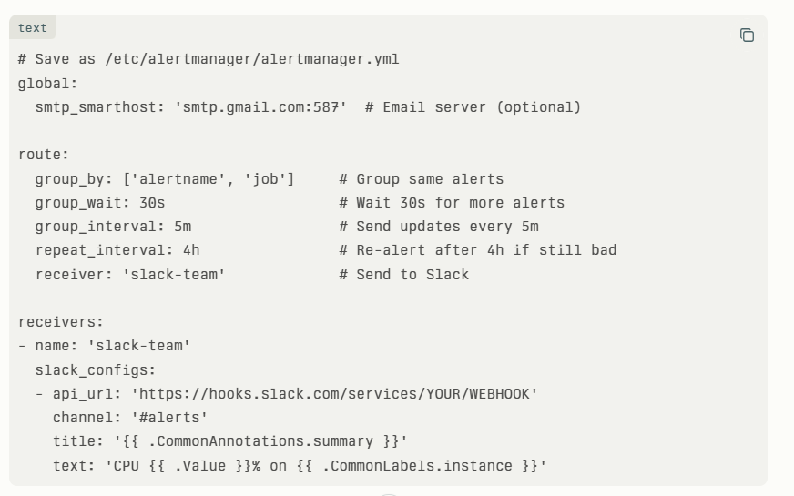

Server Level:

Grafana shows Linux server at 60% CPU → Immediate action plan for your DevOps role
devops reaction to this issues
